A Project Report

On

Employee Management System

Created By

**SHRUTI R. SADANI**

**PGDCA SEM-2**

Under The Guidance of

**PROF.HARSH JOSHI**

Submitted To

**GEETANJALI COLLEGE OF COMPUTER SCIENCE & COMMERCE**



Affiliated To

**SAURASTRA UNIVERSITY**

For Academic Year

**2022-23**

**Acknowledgement**

The project on EMPLOYEE MANAGEMENT SYSTEM is developed in html,css,java and php Language at GEETANJALI COLLEGE OF COMPUTER SCIENCE & COMMERCE.

I would like to acknowledge that my project has been completed and I am ensuring that, in this accomplishment,I would like to express my special gratitude to all my teachers and specially **PROF.HARSH JOSHI**  without their guidance and feedback it is not possible to complete this assignment.

**INDEX**

|  |  |
| --- | --- |
| * Introduction * Abstract * Purpose * Project Profile * SDLC process model * Software resources * List of Modules * Data Dictionary * Data flow chart * Context Diagram * Level 1 * Use case diagram * Testing – Test cases * Sreenshot * Limitations * Future Enhancement * Conclusion * Webliography | 5  6  7  9  9  10  12  13  14  14  18  31  31  32  32 |

**INTRODUCTION**

**Abstract:**

The main objectives of this project are to maintain information about employee other activities like add employee,assign project ,employee leave as well as employee can view and request for leave.

Admin can add new employee.

**Purpose:**

The objective of the Employee Management Project is to allow the administrator of any organization to edit and find out the personal details of an employee and allows the employee to keep up to date with his profile.

**Project Profile**

**Project Title** : Employee Management System

**Development Software** : Notepad ++

**Back End Tool :** SQL Server

**Academic Year:** 2022-23

**Development By:** SHRUTI R. SADANI

**Submitted To:**  GEETANJALI COLLAGE

# Process Model

The Process Model used in our projects "Employee Management System" is waterfall model.

#### The Waterfall Model:

The waterfall model is a sequential design process, used in software development processes, in which progress is seen as flowing steadily downwards (like a waterfall) through the phases of Conception, Initiation, Analysis, Design, Construction, Testing,Production/Implementation and Maintenance.

The waterfall development model originates in the manufacturing and construction industries: highly structured physical environments in which after-the-fact changes are prohibitively costly, if not impossible. Since no formal software development methodologies existed at the time, this hardware-oriented model was simply adapted for software development.

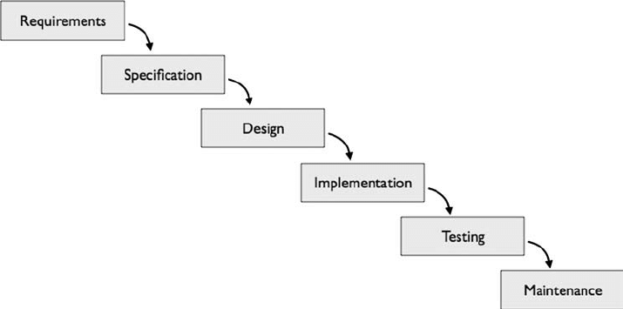

#### Reason the waterfall model in the software development cycle:

→ Since we have well known, clean and fixed requirements therefore it best suits for our software development.

→ Our product definitions are stable.

→ Technology is clearly understood.

→ The project is short.

##### **Advantages of the waterfall model:**

→ This model is simple and easy to understand and use. In, this model phases are processed and completed one at a time and phases do not overlap.

→ Waterfall model works well for smaller projects where sequence is very well understood.

**Software Resources**

**Backend Design Tool :** XAMMP,SQL

**Code behind language:** HTML,CSS,JAVA SCRIPT,PHP

**Functionality:**

* + Login / Logout
  + Add,Update and View employee details
  + Salary status
  + Assign project
  + View project status
  + View employee leave status

**List of modules**

* + - Login
    - Employee modules
    - Salary modules
    - Project modules
    - Leave modules

**Data Dictionary**

**Alogin Table:**

|  |  |  |
| --- | --- | --- |
| **Columns** | **Datatype** | **Constraints** |
| Id | Int | PK |
| Email | TINYTEXT | None |
| Password | LONGTEXT | None |

**Add_emp table:**

|  |  |  |
| --- | --- | --- |
| **columns** | **Datatype** | **Constraints** |
| id | Int | PK |
| full_name | Varchar(50) | NOT NULL |
| email | Varchar(50) | NOT NULL |
| password | Varchar(10) | NOT NULL |
| birthdate | Date | NOT NULL |
| gender | Varchar(10) | NOT NULL |
| contact_no | Varchar(10) | NOT NULL |
| address | Varchar(50) | NULL |
| department | Varchar(10) | NOT NULL |
| degree | Varchar(15) | NOT NULL |
| salary | Int(10) | NOT NULL |
| pic | Text | NOT NULL |

**Salary table:**

|  |  |  |
| --- | --- | --- |
| **Columns** | **Datatype** | **Constraints** |
| Id | Int(11) | PK |
| Base | Int(11) | NOT NULL |
| Bonus | Int(11) | NULL |
| Total | Int(11) | NULL |

**Project table:**

|  |  |  |
| --- | --- | --- |
| **Columns** | **Datatype** | **Constraints** |
| pid | Int(11) | PK |
| Eid | Int(11) | NULL |
| pname | Varchar(100) | NULL |
| Duedate | Date | NULL |
| Subdate | Date | NULL |
| Mark | Int(11) | NOT NULL |
| Status | Varchar(50) | NULL |

**Rank table:**

|  |  |  |
| --- | --- | --- |
| **Columns** | **Datatype** | **Constraints** |
| Eid | Int(11) | NOT NULL |
| Points | Int(11) | NULL |

**Employee leave table:**

|  |  |  |
| --- | --- | --- |
| **Columns** | **Datatype** | **Constraints** |
| Token | Int(11) | PK |
| id | Int(11) | NOT NULL |
| full_name | Varchar(50) | NOT NULL |
| start | Date | NULL |
| end | Date | NULL |
| reason | Varchar(100) | NULL |
| status | Varchar(50) | NULL |

**DFD [Data Flow Diagram]**

|  |  |
| --- | --- |
| **Symbol** | **Description** |
| dfd symbol | **Data Flow** – Data flow are pipelines through the packets of information  flow. |
|  | **Process :** A Process or task performed by the system. |
|  | **Entity :** Entity are object of the system. A source or destination data of a system. |
| dfd source symbol | **Data Store :** A place where data to be stored. |

* **DFD 0 level diagram(Context Diagram):-**

**Login**

**Admin**

**Addd Database**

**Emp data**

**Employee**

**Database**

* Level 1 DFD:

**ADMIN LOGIN**

LOG- OUT

LEAVE

PROJECT

STATUS

PROJECT ASSIGN

SALARY

VIEW

EMPLOYEE

ADD EMPLOYEE

HOME

**Employee login**

**Logout**

**Leave**

**Project**

**Status**

**Employee**

**data**

**Employee**

**profile**

* ERD [Entity Relationship Diagram]:

id

Employee

Admin

* **Use case diagram:**

**Manage emp information**

**Manage Employee**

**Admin**

**Employee**

**Manage Employee**

**Salary**

**Manage Employee**

**Project**

Leave info

**Manage Employee**

**Leave**

Leave report

Record leave

Test Cases:

The testing phase is an important part of the software developed. It is the

process of finding errors and missing operations and a complete verification

to determine whether the objectives are met and the user requirements

are satisfied.

**Login Screen:**

|  |  |  |  |  |
| --- | --- | --- | --- | --- |
| **Serial no.** | **Condition to be check** | **Test data** | **Expected Output** | **Remarks** |
| 1. | If Fields are empty | Value of  form fields. | Alert the user  to enter  the fields and  then  proceed. | SUCCESSFUL |
| 2. | If incorrect  username or  password | Value of Textbox  of Username &  password | Alert user that  “Invalid  Username or  password”  And stay in  same page. | SUCCESSFUL |

Employee Add & Edit Screen:

|  |  |  |  |  |
| --- | --- | --- | --- | --- |
| **Serial no.** | **Condition to be**  **Check** | **Test Data** | **Expected**  **Output** | **Remarks** |
| 1. | If Fields are empty | Value of  form fields. | Alert the user  to enter  the fields and  then  proceed. | SUCCESSFUL |
| 2. | If Email is not in  proper format | Value of Textbox  of email | Alert user that  “Email Must  be in proper  Format  ” And stay in  same page. | SUCCESSFUL |
| 3. | If alphabets input  in Phone no field | Value of Phone  No Text Field | Alert user that  “Only digits  are Allowed” | SUCCESSFUL |
| 4. | If Phone NO Value  < 10 | Value of Phone  No Text Field | Alert user that  “Phone no  length must  be 10 digits” | SUCCESSFUL |
| 5. | If user search for  student, whose  data is not  available | Value of Filter  Text Field | Alert user that  “No Records  Found” | SUCCESSFUL |

**Employee Salary table:**

|  |  |  |  |  |
| --- | --- | --- | --- | --- |
| **Serial no.** | **Condition to be**  **Check** | **Test Data** | **Expected**  **Output** | **Remarks** |
| 1. | If Fields are empty | Value of  form fields. | Alert the user  to enter  the fields and  then  proceed. | SUCCESSFUL |

**Employee Details Page:**

|  |  |  |  |  |
| --- | --- | --- | --- | --- |
| **Serial no.** | **Condition to be**  **Check** | **Test Data** | **Expected**  **Output** | **Remarks** |
| 1. | If Fields value are empty | Value of form text fields. | Alert the user to enter the field value | SUCCESSFUL |
| 2. | If inputs Duplicate values | Value of all fields | Alerts the user that “Duplicate  value found” | SUCCESSFUL |

**Create New User Page:**

|  |  |  |  |  |
| --- | --- | --- | --- | --- |
| **Serial no.** | **Condition to be**  **Check** | **Test Data** | **Expected**  **Output** | **Remarks** |
| 1. | If Any Field value is  Empty | Value of  form text fields. | Alert the user  to enter  the field value | SUCCESSFUL |
| 2. | If password &  Conform password  does not match | Value Of  Password &  Conform  Password Fields | Alerts The  user That  “Password  Characters  Does not  match” | SUCCESSFUL |

* **Screenshots:**
* **Main page:**

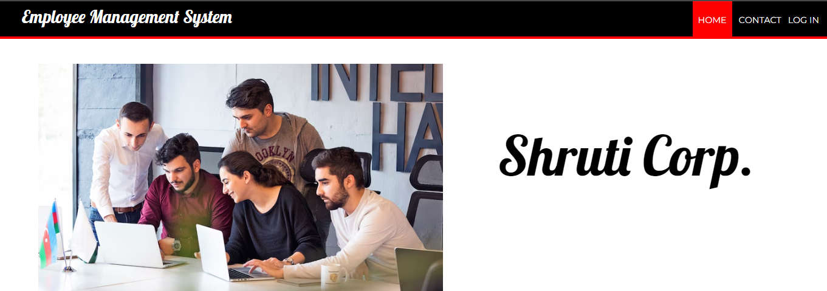

* In Employee Management system first page is Home page.
* In Home page,admin,employee login menu also and employee can contact also.
* **Admin Login page**:

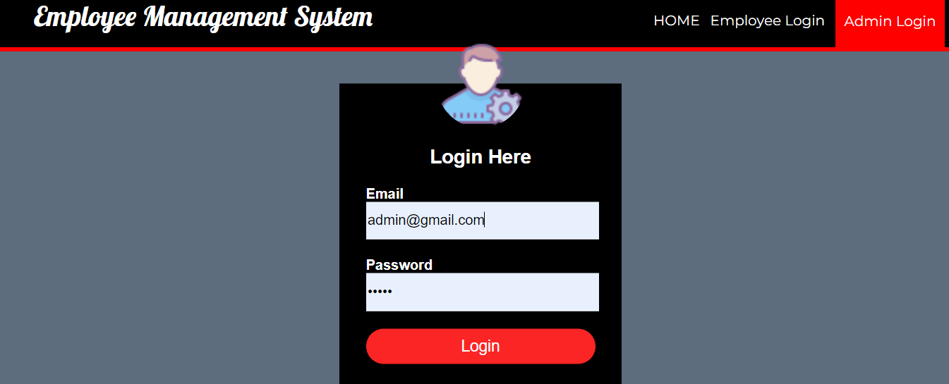

* This is Admin login page.
* Admin can log in. in this page and see all details and manage employees from admin side.
* In this page Admin must give email and password then admin can login in in this page.
* **Home page employee leaderboard**:

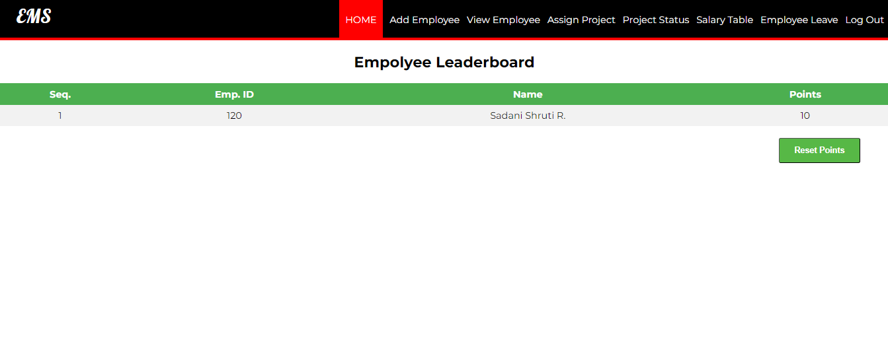

* This is Employee leaderboard page in Home.
* In leaderboard page employee’s points about their project’s mark.
* Admin can reset their points by Reset points button.

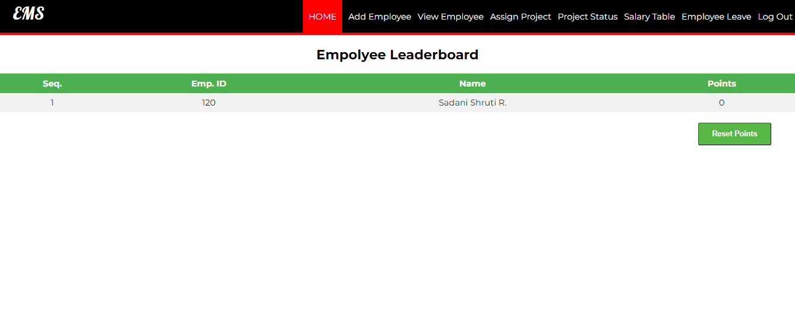

* We can see here both of employee’s points are Reset point.
* **Add Employee:**

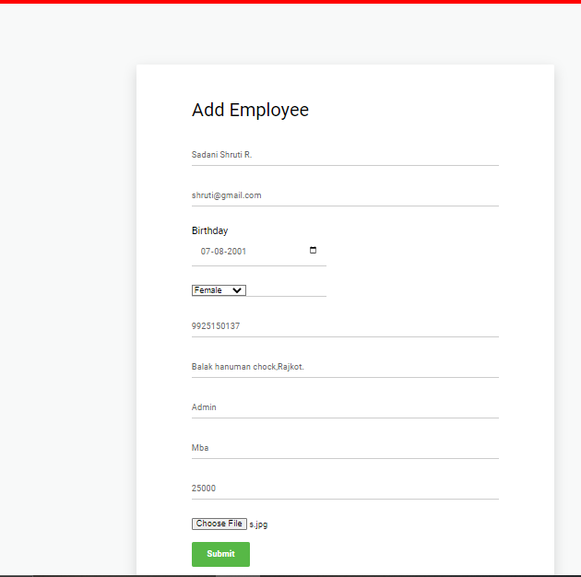

* This is Add employee page.
* In this page admin can add new employees and that employees shows in view table.
* **View table:**

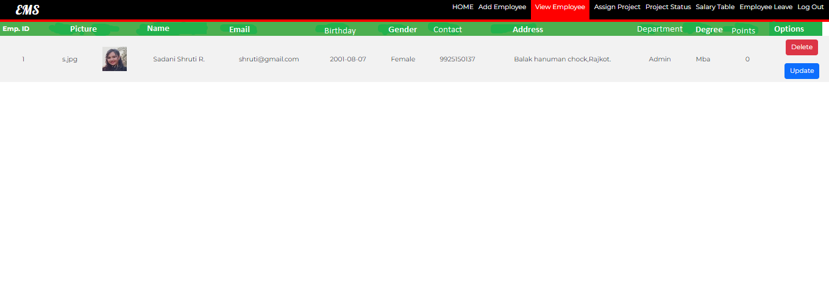

* **Assign Project table:**

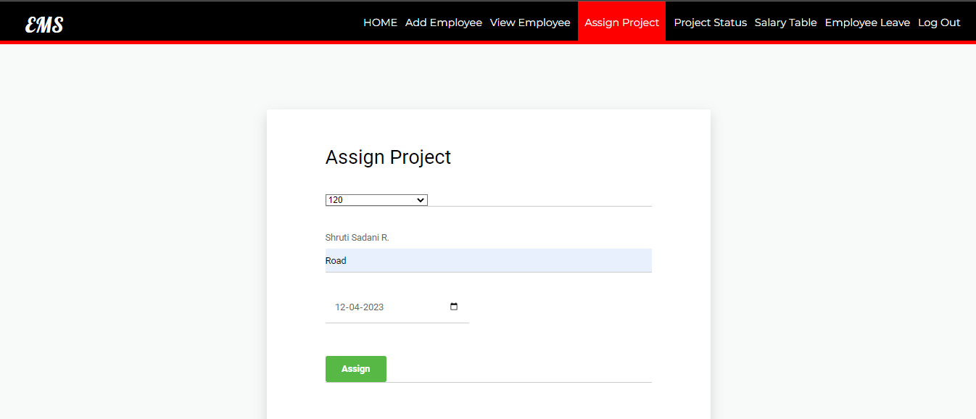

* This is Project assign table page.
* In this page Admin can assign project to their employee with their employee id.
* **Project status:**

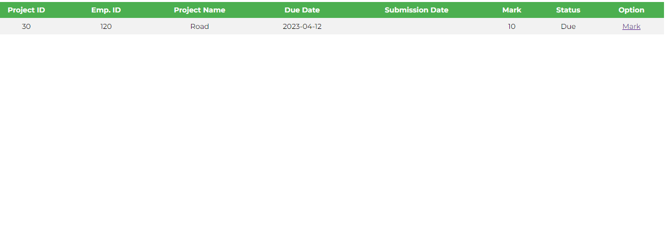

* Here, we can see employee’s project status.
* In this page project is due by employee, when employee submit their project then submission date automatic show in submission date.
* In this page we have to mark option, with this option admin can give mark from their project and they are count as employee’s points and they will show in employee leaderboard.
* **Salary table:**

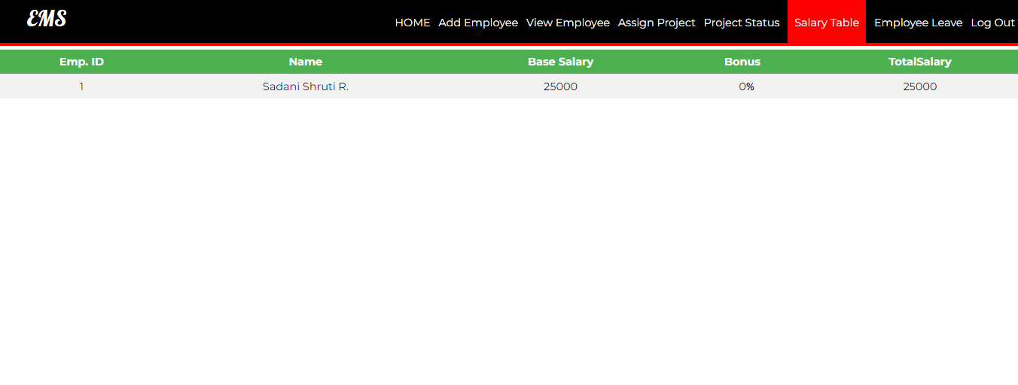

* Here, this page is Salary table page.
* Base salary , bonus and total salary is we can see here.
* **Apply leave table:**

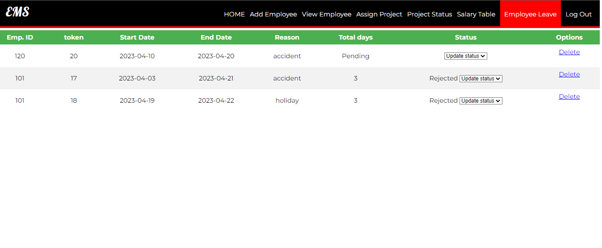

* This is apply leave page.
* In this page Admin can see which employee put leave request and admin can Approve OR Reject employee’s request till then their leave status is show pending request.
* When admin approve or reject theire leave request then status update and show request approve or not.

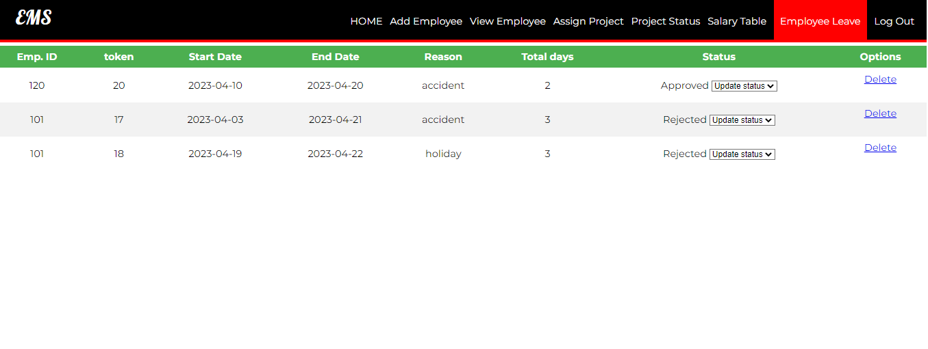

* Here we can see admin approve emp.id 120 ‘s request approved and status show Approved.
* Here admin can delete leave request also.
* **Logout:**

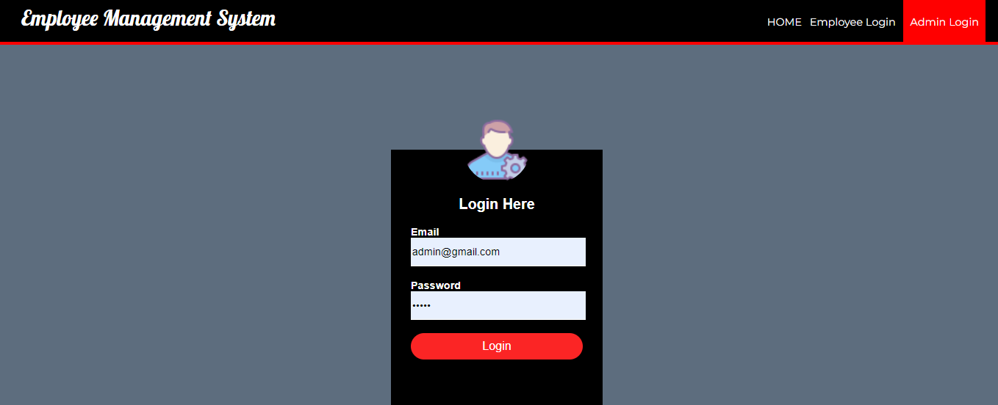

* Here, when admin go for logout then admin come in home page .
* **Employee login page:**

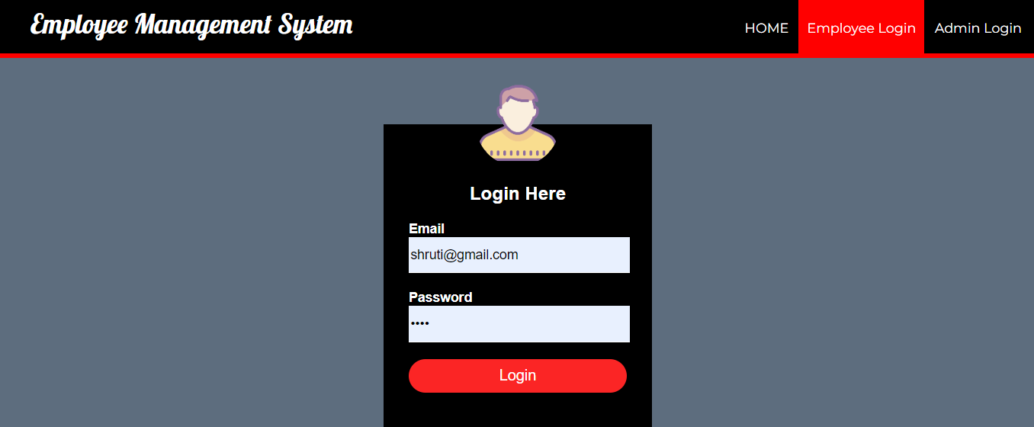

* Here, this is employee login page.
* Here, employee can login in this page and they can show there own details, their profile and they can put their leave request ,etc.
* Employee must give email and password then employee can open their account.
* **Employee home page:**

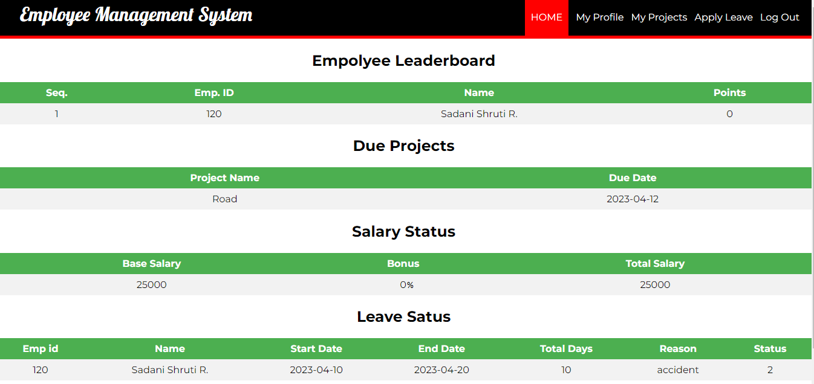

* This is employee home page .
* In this page employee can show their activities,points ,project status,salary status and their leave status.
* **Employee profile:**

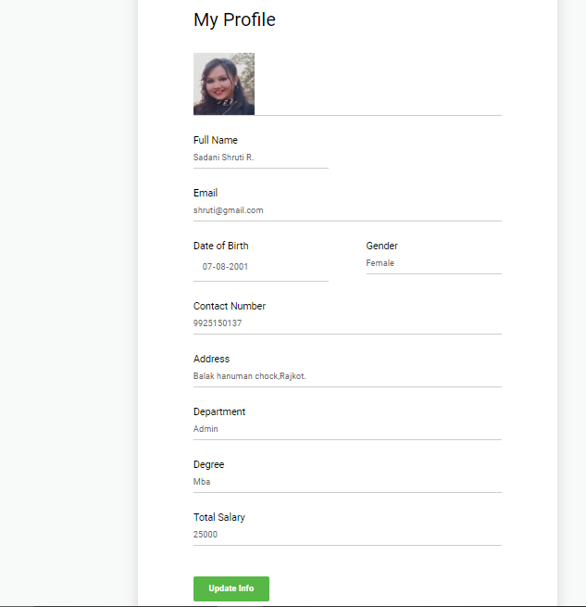

* This is employee profile page.
* In this page employee can see their own profile by their email and password.
* Employee can update their email address, contact no. and their address.

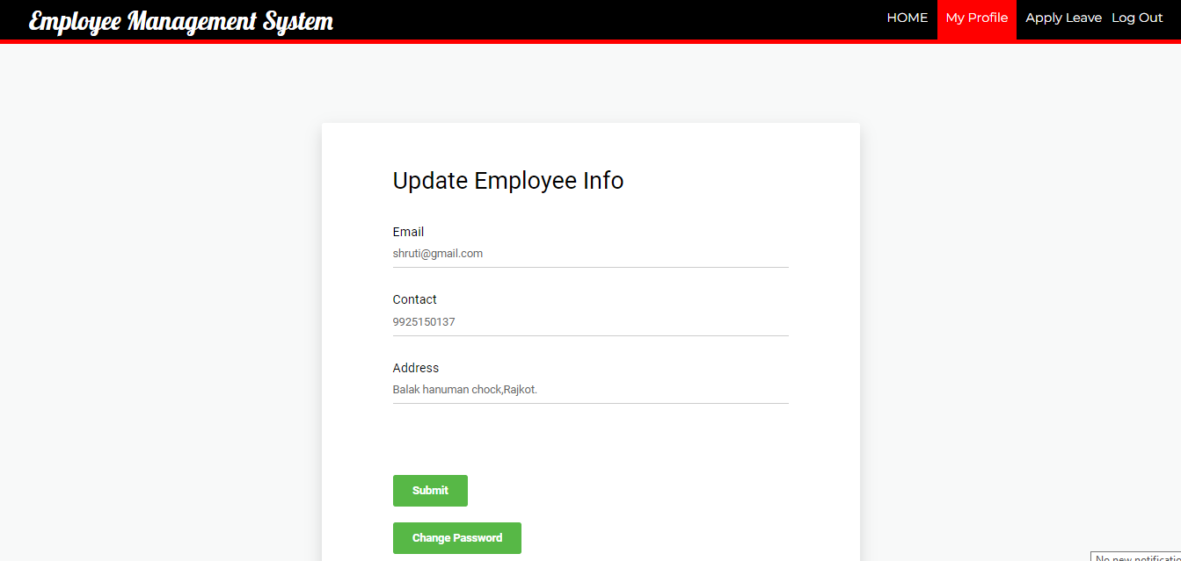

* Here employee can update their email, contact no. and address .
* Employee also change their password.
* **Employee project status page:**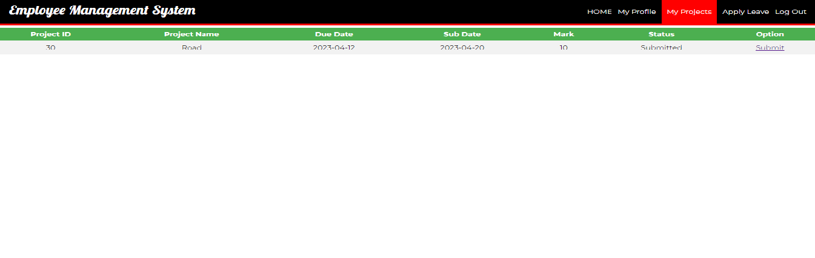
* Here, employee can see their project status and here, employee can submit their project .
* When employee submit their project submit date automatic show in sub date.
* **Apply leave page:**

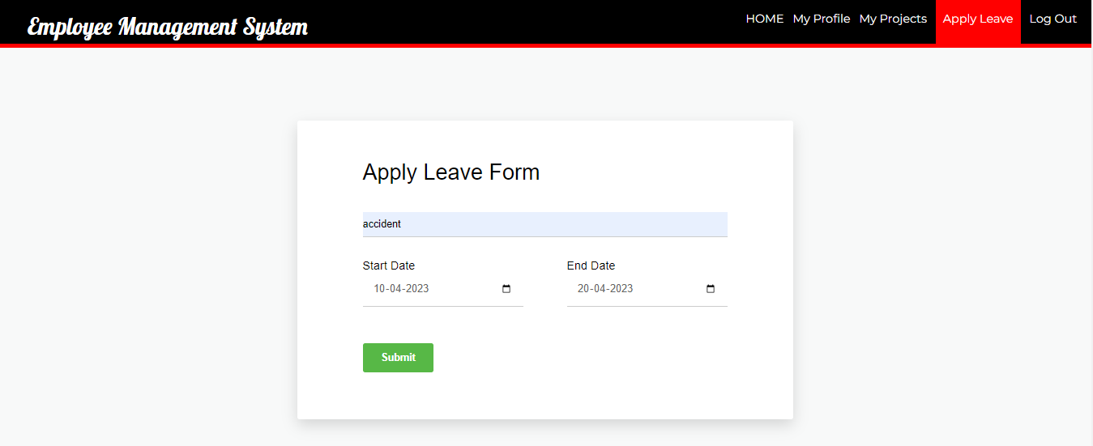

* In this page employee can apply leave with this form.
* When employee put leave request then that request show below this form and employee’s home page with the status of pending.

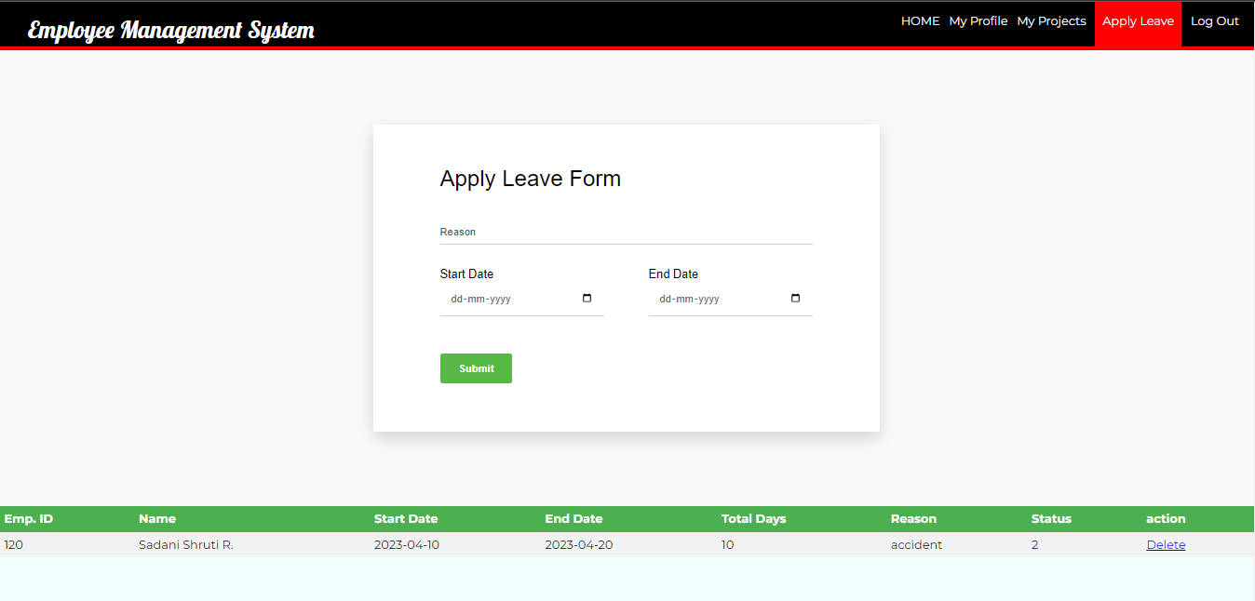

* Here, we can show employee leave request below leave form.
* **Logout:**

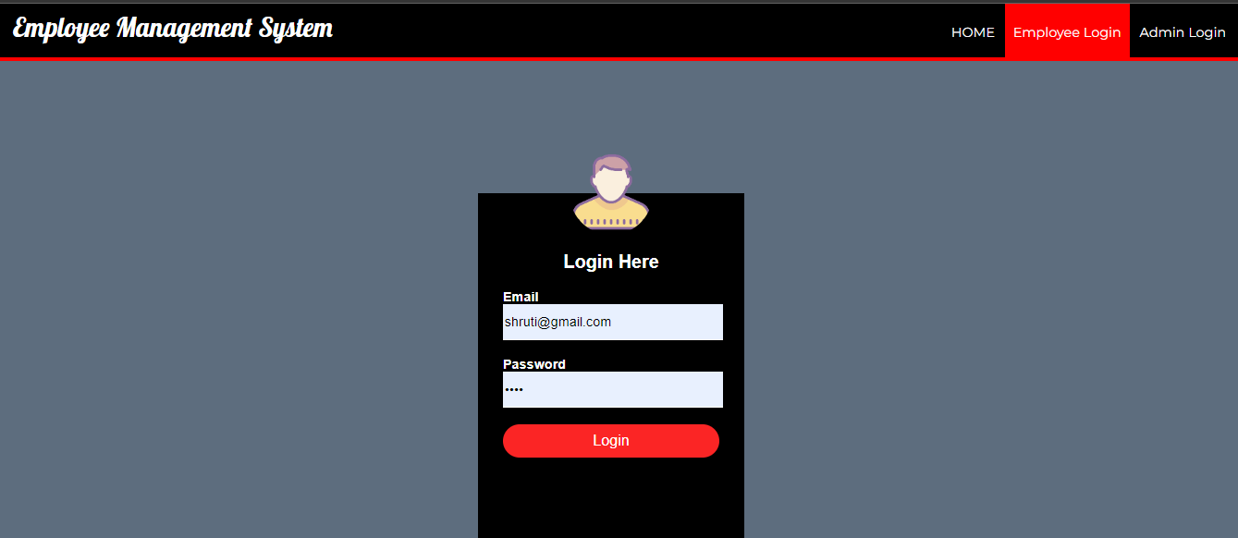

* When employee logout from their page employee come in admin home page.
* **Contact page:**

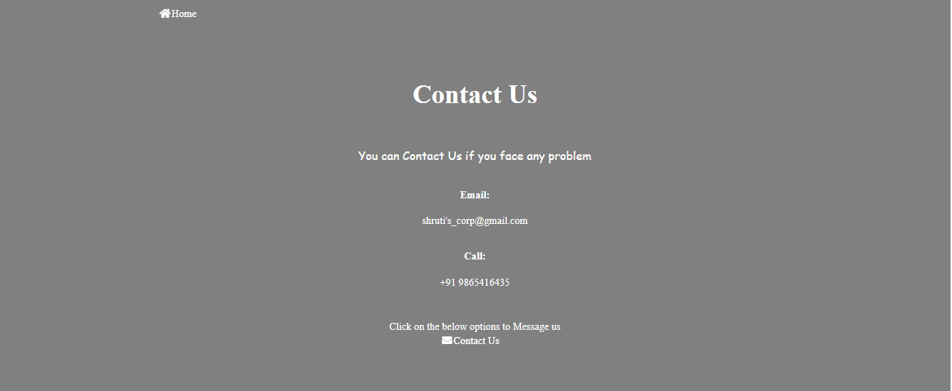

* This is contact page .
* Employee can contact by this page and when employee want put a message then they have to click contact us page .
* And when employee want go to home then they can click home button by that button.
* **Contactus page:**

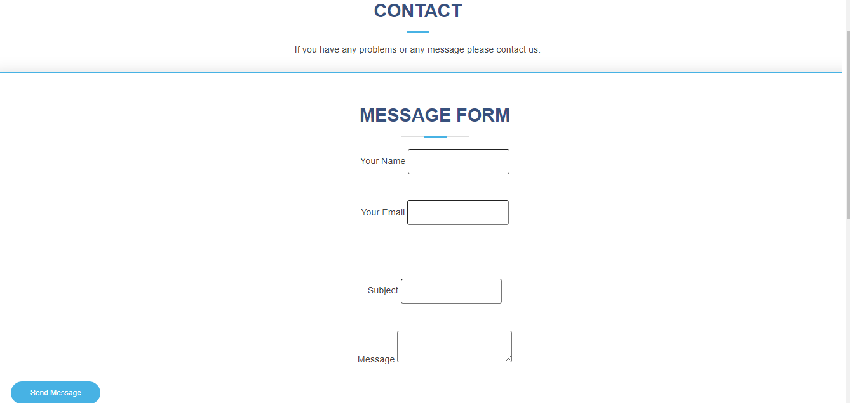

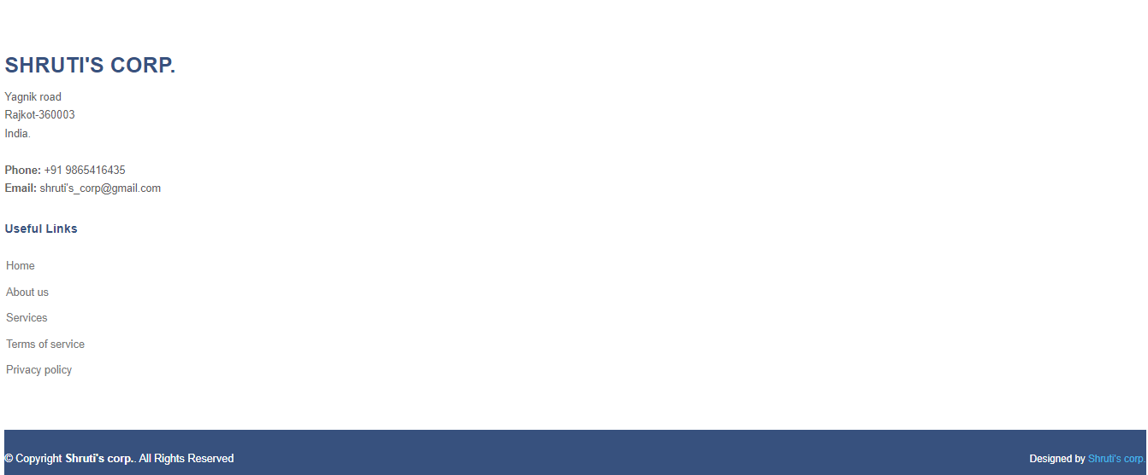

* This is contact page ,where employee can contact and put message.
* **Limitations:**

Though we tried our best in developing this software but as limitation are major part of any software so are of our software. Some limitation of innovator to investors portal are as follows:

→ Limited functionality is available.

→ If database gets big amount of data, it gets much time to load.

→ Specific user roles are not provided in this software. That’s why this can

only be used by admin.

* Future Enhancement

To conclude, Project data grid works like a component which can access all the

databases and pick-ups different function by admin. Trying to remove the many limitations and add some more functionality in future.

• Account Module would be implemented with all features as per user

requirements.

• In Login module employee will be added as user so they can use CMS.

• It would be more user-friendly software.

• We would give more advance software of CMS with more functionality.

• Will Implement the backup mechanism to take Backup of database.

* Conclusion:

The project entitled as Employee Management System is the system that deals with the all employees.

• This project is successfully implemented with all the features mentioned in system requirements specification.

• The application provides appropriate information to users according to the choosen service.

• The project is designed keeping in view the day-to-day problems faced by a company.

Deployment of our application will certainly help the company to reduce unnecessary wastage of time in personally going to each department for some information.

Awareness and right information about any company is essential for both the development of employee as well as faculty. So, this serves the right purpose in achieving

the desired requirements of both the communities.

* Webliography:
* <https://stackoverflow.com/>
* <https://w3schools.com/>
* <https://www.geeksforgeeks.org/>